CURRICULUM VITAE OF FACULTY MEMBERS

1. Personal Information
Full Name: CHANDAN KUMAR DAS
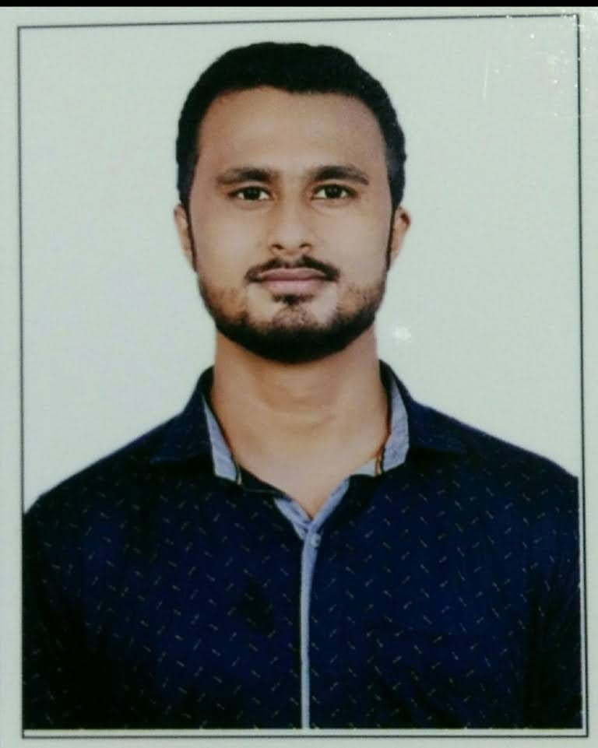
Designation: LECTURER
Department: COMMERCE
Date of Birth: 08.04.1998
Date of Joining:02.03.2024
Gender: MALE Photo
Official Address: SALIPUR AUTONOMOUS COLLEGE, SALIPUR
Email: daschandan6161@gmail.com
Phone:9861396161
ORCID/Research ID (if any):

2. Academic Qualifications
Degree | Specialization | University/Board | Year | Percentage/CGPA
10th | FLO,SLE,TLS,MATH | BSE ODISHA | 2013 | 72.67%
12th | SCIENCE(PHY,CHEM,MATH,BIO) | CHSE ODISHA | 2015 | 57.33%
Graduation | ACCOUNTING AND FINANCE | UTKAL UNIVERSITY | 2018 | 72.71%
Post Graduation | M.COM(FINANCE) | RAVENSHAW UNIVERSITY | 2020 | 74.25%
M.Phil.
UGC/CSIR NET-JRF | UGC NET-JRF | UGC | 2022 | 69.33%
CMA-INTERMEDIATE | CMA-INTER | ICMAI | 2021 | 69.00%
Ph.D. | Ph.D. | UTKAL UNIVERSITY | CONT..

3. Teaching Experience
Designation | Institution | From | To | Total Experience
LECTURER | GUNUPUR COLLEGE, GUNUPUR | 02.03.2024 | 30.06.2025 | 1 YEAR, 3 MONTHS AND 28 DAYS
LECTURER | SALIPUR AUTONOMOUS COLLEGE, SALIPUR | 01.07.2025 | CONT…. | 7 MONTHS AND 17 DAYS

4. Courses Attended (Orientation/Refresher/FDP etc.)
Course | Date | University/Organization | State/National / International
Research Ethics | 19.07.23-21.07.23 | UTKAL UNIVERSITY(UGC SPONSORED) | NATIONAL

5. Seminars / Conferences Attended / Participated
Date | Topic | Organized By | Sponsored By | Role (Participated/Presented/Organized) | National / International

6. Research Publications
Title of the Paper | Name of the Journal | Impact Factor | ISSN No. | Volume | Issue | Year

7. Membership in Organizations / Associations
Position Held | Organization (National/State/International) | Type of Membership | Activities Conducted (Subject Expert/Guest Lecturer/BOS Member/Life Member etc.)

8. Areas of Specialization / Research Interests
ACCOUNTING AND FINANCE

9. Awards / Recognitions (if any)

Declaration
I hereby declare that the information provided above is true to the best of my knowledge.
Date: 17.02.2026
Place: SALIPUR
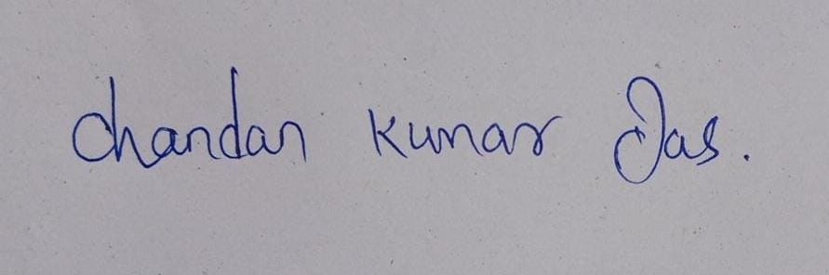
Signature

