CURRICULUM VITAE OF FACULTY MEMBERS

1. Personal Information
Full Name: Sriparna Ghose
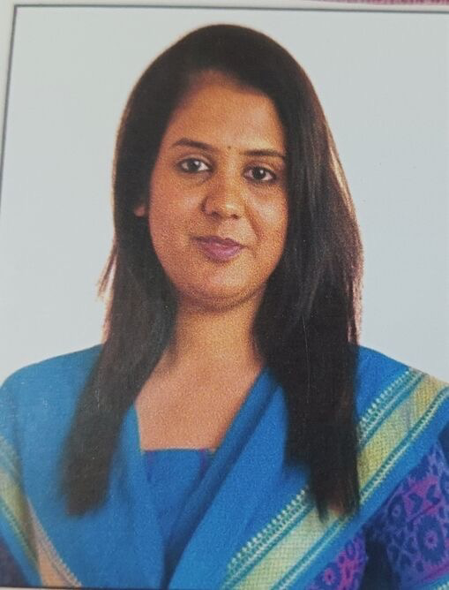
Designation: Lecturer in P.G Department of Education
Department: Education
Date of Birth: 06/01/1997
Date of Joining: 18/05/22
Gender: Female Photo
Official Address: Salipur Autonomous College, Salipur, Cuttack
Email: Sriparna.nupur@gmail.com
Phone: 8917299011
ORCID/Research ID (if any):

2. Academic Qualifications
Degree | Specialization | University/Board | Year |  | Percentage/CGPA
10th |  | BSE | 2013 |  | 75.83
12th |  | CHSE | 2015 |  | 76.83
Graduation | EDUCATION (HON)  POL.SC | Ravenshaw University | 2018 |  | 70.13
Post Graduation | EDUCATION | Ravenshaw University | 2020 | 77.50
M.Phil. | EDUCATION | Ravenshaw University | 2021 | 75.17
UGC NET | EDUCATION | University Grants Commission | 2020
Ph.D.

3. Teaching Experience
Designation | Institution | From | To | Total Experience
Lecturer in P.G Dept of Education | Salipur Autonomous College | 18/05/2022 | Continue | 3 years 8 months

4. Courses Attended (Orientation/Refresher/FDP etc.)
Course | Date | University/Organization | State/National / International
FDP | 15/05/23 TO 26/05/23 | RAVENSHAW UNIVERSITY | NATIONAL - ICSSR
WORKSHOP | 29/06/2023 | ELSEVIER | INTERNATIONAL
WORKSHOP | 02/01/2026 TO 12/01/2026 | ESSGEE DIGISKILLS | NATIONAL
WORKSHOP | 22/7/2024 TO 26/07/2024 | GURU GHASIDAS VISHAWVIDYALAYA, BILASPUR, CENTRAL UNIVERSITY | NATIONAL
ONLINE TRAINING | 07/04/2025 to 11/04/2025 | DHANALAKSHMI SRINIVASAN COLLEGE OF ENGINEERING AND TECHNOLOGY | NATIONAL
REFRESHER COURSE | 10/12/2024 TO 23/12/24 | TEZPUR UNIVERSITY | NATIONAL

5. Seminars / Conferences Attended / Participated
Date | Topic | Organized By | Sponsored By | Role (Participated/Presented/Organized) | National / International
06/08/2025 to 07/08/25 | TRANSFORMING TEACHER PROFESSIONAL DEVELOOMENT FOR AI-INTEGRATED INCLUSIVE CLASSROOM | DEPARTMENT OF EDUCATION &B.ED. DHARANIDHAR UNIVERSITY KEONJHAR | DHARANIDHAR UNIVERSITY, KEONJHAR | PRESENTED | NATIONAL

6. Research Publications
Title of the Paper | Name of the Journal | Impact Factor | ISSN No. | Volume | Issue | Year
ATTITUDE OF PUPIL TEACHERS TOWARDS INCLUSIVE EDUCATION IN ODISHA | INTERNATIONAL JOURNAL OF SCIENTIFIC DEVELOPMENT AND RESEARCH |  | 2455-2631 | 6 | 11 | NOVEMBER 2021
360-DEGREE HOLISTIC ASSESSMENT IN SCHOOL EDUCATION : AN ANALYSIS OF NEP 2020 AND ITS CHALLENGES | INTERNATIONAL JOURNAL FOR MULTIDISCIPLINARY RESEARCH |  | 2582-2160 | 6 | 6 | NOVEMBER- DECEMBER 2024
GLOBAL CITIZENSHIP IN HIGHER EDUCATION: THE ROLE OF TEACHERS IN 21ST CENTURY | MULTIDISCIPLINARY AND MOTHER TONGUE BASED HIGHER EDUCATION |  |  |  |  | NOVEMBER 2024

7. Membership in Organizations / Associations
Position Held | Organization (National/State/International) | Type of Membership | Activities Conducted (Subject Expert/Guest Lecturer/BOS Member/Life Member etc.)

8. Areas of Specialization / Research Interests
TEACHER EDUCATION & EDUCATIONAL MANAGEMENT

9. Awards / Recognitions (if any)

Declaration
I hereby declare that the information provided above is true to the best of my knowledge.
Date: 18/02/2026
Place: SALIPUR, CUTTACK
Sriparna Ghose
Signature

