CURRICULUM VITAE OF FACULTY MEMBERS

Personal Information
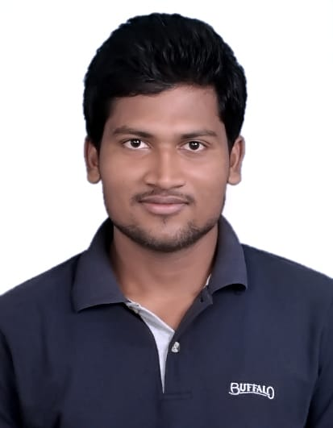
Full Name: DEEPAK KUMAR NAYAK
Designation: LECTURER
Department: PHYSICS
Date of Birth: 21/07/1993
Date of Joining:17/10/2016
Gender: MALE
Official Address: SALEPUR AUTONOMOUS COLLEGE, SALEPUR, CUTTACK
Email: deepakgudu1993@gmail.com
Phone: 8984696830

2. Academic Qualifications
Degree | Specialization | University/Board | Year | Percentage
10th |  | BSE, WEST BENGAL | 2008 | 78.5%
12th | SCIENCE | CHSE, ODISHA | 2010 | 73.5%
Graduation | PHYSICS | DHENKANAL AUTO. COLLEGE DHENKANAL | 2013 | 75.05%
Post Graduation | APPLIED PHYSICS & BALLISTICS | FAKIR MOHAN UNIVERSITY, BALASORE | 2015 | 77.00%

3. Teaching Experience
Designation | Institution | From | To | Total Experience
LECTURER IN PHYSICS | ISPAT AUTONOMOUS COLLEGE, ROURKELA | 17/10/2016 | 30/06/2025 | 9Yrs.
LECTURER | SALEPUR AUTONOMOUS COLLEGE, SALEPUR | 01/07/2025 | Cont. | Cont.

4. Courses Attended (Orientation/Refresher/FDP etc.)
Course | Date | University/Organization | State/National / International
FACULTY INDUCTION PROGRAMME | 05 Jan 2022-  01 Feb 2022 | SAMBALPUR UNIVERSITY | UGC Sponsored
FACULTY DEVELOPMENT PROGRAM | 13 Dec 2021-  18 Dec 2021 | FAKIR MOHAN UNIVERSITY | HRDC Sponsored
REFRESHER COURSE | 08 Feb 2021-  20 Feb 2021 | IIT, DHANBAD | TEQIP Sponsored

Declaration
I hereby declare that the information provided above is true to the best of my knowledge.
Date: 18.02.2026
Place: Salipur
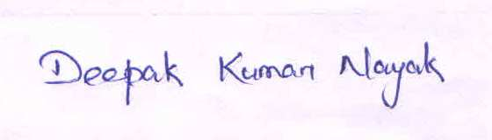
Signature

