CURRICULUM VITAE OF FACULTY MEMBERS

1. Personal Information
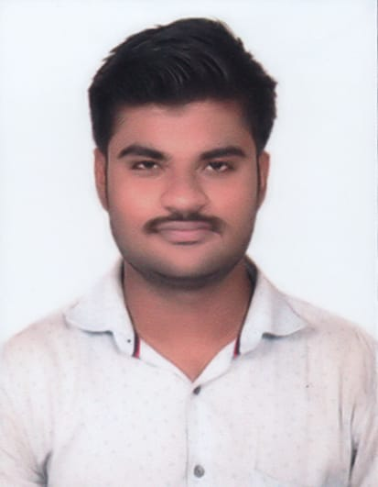
Full Name: KSHIROD KUMAR MISHRA
Designation: LECTURER IN ECONOMICS
Department: ECONOMICS
Date of Birth: 15/12/1996
Date of Joining: 01/03/2024
Gender: MALE Photo
Official Address: SALIPUR AUTONOMOUS COLLEGE, PIN- 754202
Email: kshirodkumar290@gmail.com
Phone: 9348249785
ORCID/Research ID (if any):

2. Academic Qualifications
Degree | Specialization | University/Board | Year | Percentage/CGPA
10th | FLO,SLE,TLS,MTH,SCP,SCL,SSG,SSH | BSE | 2012 | 45%
12th | MIL,ENG,POL.SC,EDU,SOC,ECO | CHSE | 2014 | 58.33%
Graduation | MIL,END,INDIAN POLITY,ECONOMICS | UTKAL UNIVERSITY | 2017 | 67.05%
Post Graduation | ECONOMICS | BERHAMPUR UNIVERSITY | 2019 | 72.05%
M.Phil.
UGC/CSIR NET-JRF | ECONOMICS (JRF) | NTA UGC-NET | 2022 | 70.66%
Ph.D.

3. Teaching Experience
Designation | Institution | From | To | Total Experience
LECTURER IN ECONOMICS | SALIPUR AUTONOMOUS COLLEGE | 01/03/2024 | TILL DATE | 1 YEAR 11 MONTHS

4. Courses Attended (Orientation/Refresher/FDP etc.)
Course | Date | University/Organization | State/National / International
FDP | 12/09/2025-  13/09/2025 | USBM | STATE
FDP | 27/10/2025-31/10/2025 | IQAC,SRUSTI ACADEMY OF MANAGEMNET AND TECHNOLOGY | STATE

5. Seminars / Conferences Attended / Participated
Date | Topic | Organized By | Sponsored By | Role (Participated/Presented/Organized) | National / International

6. Research Publications
Title of the Paper | Name of the Journal | Impact Factor | ISSN No. | Volume | Issue | Year

7. Membership in Organizations / Associations
Position Held | Organization (National/State/International) | Type of Membership | Activities Conducted (Subject Expert/Guest Lecturer/BOS Member/Life Member etc.)

8. Areas of Specialization / Research Interests

9. Awards / Recognitions (if any)

Declaration
I hereby declare that the information provided above is true to the best of my knowledge.
Date:
Place:
Signature

