CURRICULUM VITAE

1. Personal Information
Full Name: MANASI PRIYADARSHINI MALLICK
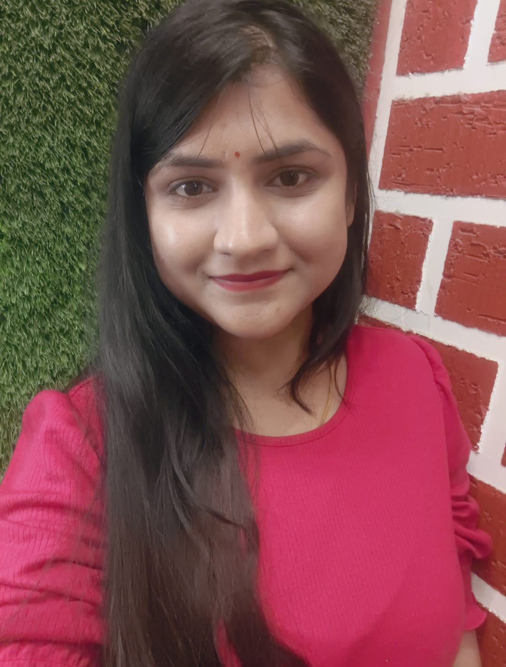
Designation: LECTURER IN HISTORY
Department: Higher education of Odisha
Date of Birth: 21APRIL1998
Date of Joining: 22FEB2023
Gender: FEMALE Photo
Official Address: Salipur Autonomous College, Salipur, Pin-754202
Email: manasipriyadarshinictc@gmail.com
Phone: 9348917550
ORCID/Research ID (if any):

2. Academic Qualifications
Degree | Specialization | University/Board | Year | Percentage/CGPA
10th |  | BSE, ODISHA | 2013 | 77.5
12th |  | CHSE, ODISHA | 2015 | 70.3
Graduation |  | UTKAL UNIVERSITY | 2018 | 62.55
Post Graduation |  | UTKAL UNIVERSITY | 2020 | 72.5
M.Phil. |  | UTKAL UNIVERSITY | 2022 | 66.5
UGC/CSIR NET-JRF
Ph.D.

3. Teaching Experience
Designation | Institution | From | To | Total Experience
LECTURER | SALIPUR AUTONOMOUS COLLEGE | 22 FEB 2023 | CONTINUING | 3 YEARS

4. Courses Attended (Orientation/Refresher/FDP etc.)
Course | Date | University/Organization | State/National / International
HISTORY TEACHER TRAINING PROGRAMME | 27/01/ 2025 TO 31/01/2025 | GOVT. SCIENCE COLLEGE, CHHATRAPUR | STATE

5. Seminars / Conferences Attended / Participated
Date | Topic | Organized By | Sponsored By | Role (Participated/Presented/Organized) | National / International

6. Research Publications
Title of the Paper | Name of the Journal | Impact Factor | ISSN No. | Volume | Issue | Year

7. Membership in Organizations / Associations
Position Held | Organization (National/State/International) | Type of Membership | Activities Conducted (Subject Expert/Guest Lecturer/BOS Member/Life Member etc.)
HOD | SALIPUR AUTONOMOUS COLLEGE | CHAIRMAN | BOS

8. Areas of Specialization / Research Interests
MODERN INDIAN HISTORY

9. Awards / Recognitions (if any)

Declaration
I hereby declare that the information provided above is true to the best of my knowledge.
Date: 17/02/2026
Place: SALIPUR

Manasi Priyadarshini Mallick
Signature

