CURRICULUM VITAE OF FACULTY MEMBERS

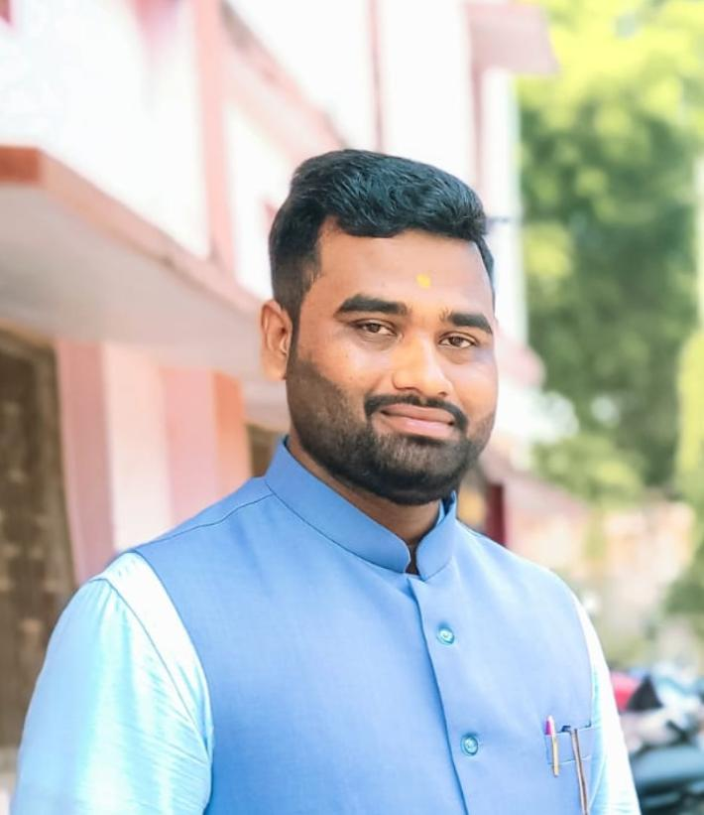
1. Personal Information
Full Name: MANTAN KUMAR BEHERA
Designation: LECTURER
Department: ENGLISH
Date of Birth: 26.06.1994
Date of Joining:02.09.2022
Gender: MALE
Official Address: SALIPUR AUTONOMOUS COLLEGE, SALIPUR, CUTTACK
Email: jitmantu8080@gmail.com
Phone: 9178091958,8249569979
ORCID/Research ID (if any):

2. Academic Qualifications
Degree | Specialization | University/Board | Year | Percentage/CGPA
10th |  | BSE,ODISHA | 2010 | 57.83
12th | ARTS | CHSE, ODISHA | 2012 | 50.17
Graduation | ENGLISH | UTKAL UNIVERSITY | 2015 | 51.67
Post Graduation | ENGLISH | RAVENSHAW UNIVERSITY | 2017 | 60.8
M.Phil.
UGC/CSIR NET-JRF | ENGLISH | NTA | 2020
Ph.D.

3. Teaching Experience
Designation | Institution | From | To | Total Experience
PGT ENGLISH | ODISHA ADARSHA VIDYALAYA CHAMPUA | 06.09.2021 | 30.08.2022 | 1 YEAR
LECTURER IN ENGLISH | SALIPUR AUTONOMOUS COLLEGE | 02.09.2022 | TILL DATE | 3YEARS

4. Courses Attended (Orientation/Refresher/FDP etc.)
Course | Date | University/Organization | State/National / International

5. Seminars / Conferences Attended / Participated
Date | Topic | Organized By | Sponsored By | Role (Participated/Presented/Organized) | National / International

6. Research Publications
Title of the Paper | Name of the Journal | Impact Factor | ISSN No. | Volume | Issue | Year

7. Membership in Organizations / Associations
Position Held | Organization (National/State/International) | Type of Membership | Activities Conducted (Subject Expert/Guest Lecturer/BOS Member/Life Member etc.)

8. Areas of Specialization / Research Interests

9. Awards / Recognitions (if any)

Declaration
I hereby declare that the information provided above is true to the best of my knowledge.
Date: 16.02.2026
Place: SALEPUR
MANTAN KUMAR BEHERA
Signature

