CURRICULUM VITAE OF FACULTY MEMBERS

1. Personal Information
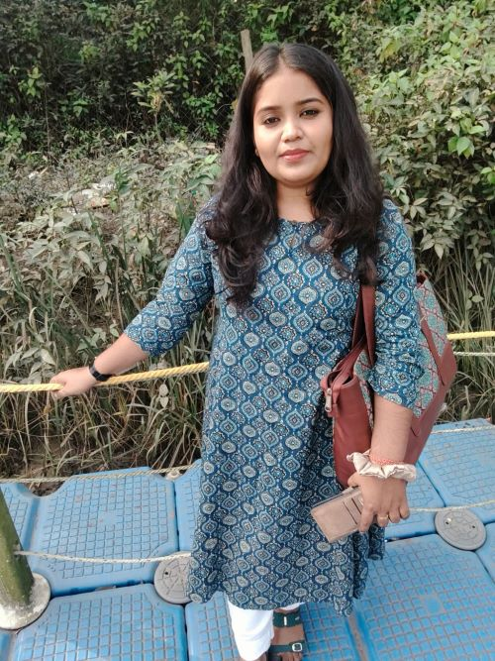
Full Name: RASMITA NAYAK
Designation: LECTURER
Department: POLITICAL SCIENCE
Date of Birth: 22/03/1997
Date of Joining:02/09/2022
Gender: FEMALE Photo
Official Address: SALIPUR AUTONOMOUS COLLEGE, SALIPUR
Email: rasmitanayak135@gmail.com
Phone: 7894361922
ORCID/Research ID (if any):

2. Academic Qualifications
Degree | Specialization | University/Board | Year | Percentage/CGPA
10th | FLO, SLE,TLH, MTH,SCI, SSG, SSH | BSE | 2012 | 81.5%
12th | ENG, ODIA, EDN, SOC, POL.SC | CHSE | 2014 | 74.83%
Graduation | POLITICAL SCIENCE | RAVENSHAW UNIVERSITY | 2017 | 71.36%
Post Graduation | POLITICAL SCIENCE | RAVENSHAW UNIVERSITY | 2019 | 79.10%
M.Phil.
UGC/CSIR NET-JRF | POLITICAL SCIENCE | NATIONAL TESTING AGENCY | 2020
Ph.D. | POLITICAL SCIENCE | REVENSHAW UNIVERSITY | PURSUING

3. Teaching Experience
Designation | Institution | From | To | Total Experience
ASST. TEACHER | GOVT.UG HIGH SCHOOL, KUKUDANGA | 17/12/2021 | 30/08/2022 | 8 MONTHS 13 DAYS
LECTURER IN POLITICAL SCIENCE | SALIPUR AUTONOMOUS COLLEGE | 02/09/2022 | CONINUING

4. Courses Attended (Orientation/Refresher/FDP etc.)
Course | Date | University/Organization | State/National / International
NEP ORIENTATION ANS SENSITIZATION PROGRAMME | 12/06/2024 TO 20/06/2024 | UGC | NATIONAL
FACAULTY INDUCTION PROGRAMME(FIP) | 17/01/2025 TO 15/02/2025 | UGC | NATIONAL
SIX DAYS BASIC TRAINING PROGRAMME ON INDIAN KNOWLEDGE SYSTEM(IKS) | 24/02/2025 TO 01/03/ 2025 | UGC | NATIONAL
REFRESHER COURSE IN RESEARCH METHODOLOGY IN RURAL STUDIES(RC) | 11/12/2025 TO 24/12/2025 | UGC | NATIONAL

5. Seminars / Conferences Attended / Participated
Date | Topic | Organized By | Sponsored By | Role (Participated/Presented/Organized) | National / International
23-24 DEC 2022 | ILLIGAL MIGRATION IN INDIA | SCHOOL OF POLITICAL SCIENCE, GMU, SAMBALPUR |  | PRESENTED PAPER | NATIONAL

6. Research Publications
Title of the Paper | Name of the Journal | Impact Factor | ISSN No. | Volume | Issue | Year
DISASTER MANAGEMENT AND PUBLIC POLICY IN INDIA: GOVERNACE, INSTITUTIONAL FRAMEWORK ANDCOMMUNITY RESILLENCE | INTERNATIONAL JOURNAL OF POLITICAL SCIENCE AND GOVERNACE | 5.92 | 2664-6021 | 7 | 11 | 2025

7. Membership in Organizations / Associations
Position Held | Organization (National/State/International) | Type of Membership | Activities Conducted (Subject Expert/Guest Lecturer/BOS Member/Life Member etc.)
MEMBER | SALIPUR AUTONOMOUS COLLEGE, SALIPUR |  | BOS

8. Areas of Specialization / Research Interests
FOREIGN POLICY AND INTERNATIONAL RELATION

9. Awards / Recognitions (if any)

Declaration
I hereby declare that the information provided above is true to the best of my knowledge.
Date: 17/02/2026
Place: SALIPUR
RASMITA NAYAK
Signature

