CURRICULUM VITAE
1.Personal Information
Full name: SUVASMITA BARIK 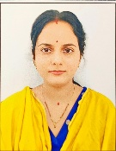
Designation: Lecturer
Department: Commerce
Date of Birth-11.05.1995
Date of Joining-02.03.2024
Gender-Female
Official Address- Salipur Autonomous College,Salipur
Email: suvasmitabarik42@gmail.com
Phone-9438584116
2.Academic Qualification

Degree/certificate | Board/university | School/college | Year of passing | percentage
M.com | IGNOU, NEW DELHI | JKBK College, Cuttack | 2018 | 61.17%
B.com | Utkal University | Salipur College, Salipur | 2015 | 58 %
12th | CHSE | Lokanath Mohavidyalaya, Korua | 2012 | 79%
10th | BSE | Tikanpur High School, Tikanpur | 2010 | 72.83%

- Qualified UGC NET December 2019

3. Teaching Experience
Designation | Institution | From | To | Total Experience
Lecturer | Salipur Autonomous College, Salipur | 02.03.2024 | Continuing

8. Arears of Specialization: Accounting & Finance

Declaration
I hereby declare that the information provided above is true to the best of my knowledge.

Date:17.02.2026
Place: Salipur 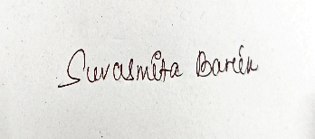
Signature

