CURRICULUM VITAE OF FACULTY MEMBERS

1. Personal Information
Full Name: Nityasundar Mishra
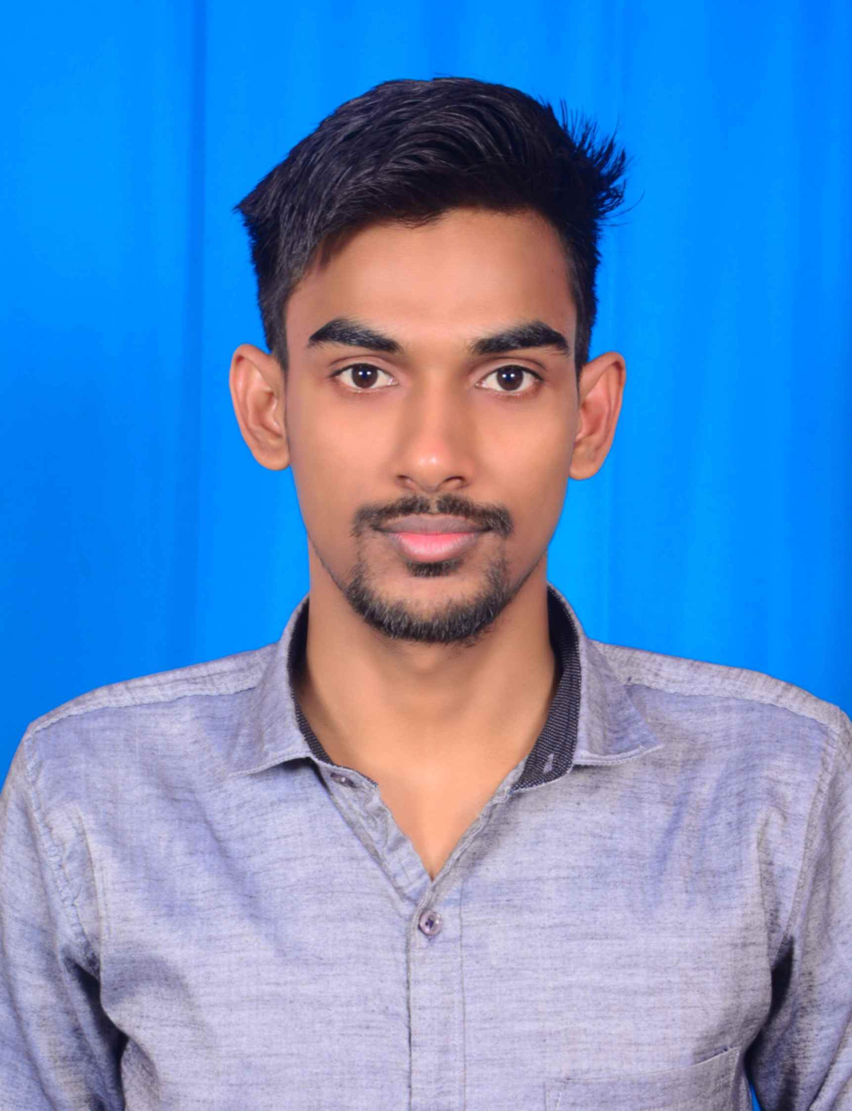
Designation: Lecturer
Department: Political Science
Date of Birth: 31/07/1996
Date of Joining: 02/09/2022
Gender: Male Photo
Official Address: Salipur Autonomous College, Salipur, Cuttack.
Email: nityasundarmishra@gmail.com
Phone: 7008519810
ORCID/Research ID (if any): 0000-0001-5711-1594

2. Academic Qualifications
Degree | Specialization | University/Board | Year | Percentage/CGPA
10th |  | BSE, Odisha | 2011 | 75.83
12th | Vocational | CHSE, Odisha | 2013 | 72.31
Graduation | Political Science | Ravenshaw University, Odisha | 2017 | 73.36
Post Graduation | Political Science | University of Hyderabad, Hyderabad | 2019 | 77.50
M.Phil. | Political Science | Utkal University, Odisha | 2020 | 69.83
UGC/CSIR NET-JRF | Political Science | UGC | 2019
Ph.D. | Political Science | Utkal University, Odisha | Pursuing

3. Teaching Experience
Designation | Institution | From | To | Total Experience
Lecturer | Salipur Autonomous College | 02/09/2022 | Till present | 3 Years 5 Months

4. Courses Attended (Orientation/Refresher/FDP etc.)
Course | Date | University/Organization | State/National / International
NEP 2020 Orientation and Sensitization Programme | 12/06/2024 to 20/06/2024 | UGC MMTTC, Sambalpur University
Faculty Induction Programme | 17/01/2025 to 15/02/2025 | UGC MMTTC, Utkal University
Basic Training Programme in Indian Knowledge System | 24/02/2025 to 01/03/2025 | UGC MMTTC, Berhampur University
Refresher Course | 11/12/2025/ to 24/12/2025 | UGC MMTTC, Utkal University

5. Seminars / Conferences Attended / Participated
Date | Topic | Organized By | Sponsored By | Role (Participated/Presented/Organized) | National / International
16/03/2024 and 17/03/2024 | India as an Emerging Economy Since Economic Reforms: Performance and Prospects | PG Department of Political Science |  | Participated | National

6. Research Publications
Title of the Paper | Name of the Journal | Impact Factor | ISSN No. | Volume | Issue | Year

7. Membership in Organizations / Associations
Position Held | Organization (National/State/International) | Type of Membership | Activities Conducted (Subject Expert/Guest Lecturer/BOS Member/Life Member etc.)
Chairman | State |  | BOS

8. Areas of Specialization / Research Interests
Political Theory, Political Thought, Tribal Studies, Welfare Politics, Gender Studies, etc.

9. Awards / Recognitions (if any)

Declaration
I hereby declare that the information provided above is true to the best of my knowledge.
Date: 17/02/2026
Place: Salipur
Nityasundar Mishra
Signature

