CURRICULUM VITAE OF PRASANTA KUMAR SAHOO

1. Personal Information

Full Name: PRASANTA KUMAR SAHOO 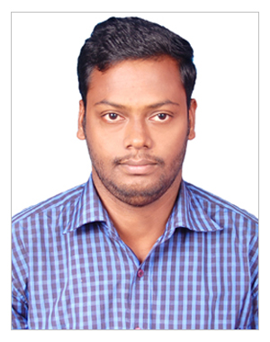
Designation: LECTURER
Department: MATHEMATICS
Date of Birth: 12-04-1990
Date of Joining: 17-10-2016
Gender: MALE
Official Address: SALIPUR AUTONOMOUS COLLEGE
Email: prasant.math156@gmail.com
Phone: 8249017142
ORCID/Research ID (if any):

2. Academic Qualifications
Degree | Specialization | University/Board | Year | Percentage/CGPA
10th | FLO,SLE,TLH,MATH,SCP,SCL,SSH,SSG | BSE | 2005 | 72.8. %
12th | ENG,MIL(O),PHY,CHEM,MATH, | CHSE | 2007 | 54%
Graduation | MATHEMATICS | RAVENSHAW UNIVERSITY | 2011 | 85.6%(hons)  77% (avg.)
Post Graduation | MATHEMATICS | PONDICHERRY UNIVERSITY | 2013 | 85.6%

3. Teaching Experience

Designation | Institution | From | To | Total Experience
LECTURER | RAYAGADA AUTONOMOUS COLLEGE | 17-10-2016 | 30-06-2025 | 9YRS
LECTURER | SALIPUR AUTONOMOUS COLLEGE | 01-07-2025 | TILL DATE

4. Courses Attended (Orientation/Refresher/FDP etc.)
Course | Date | University/Organization | State/National / International
Refresher course in Mathematical Science | 16-05-2017 to 05-06-2017 | IIT DHANBAD | NATIONAL
Orientation programme (FIP-6) | 30-08-2021 to 08-10-2021 | UGC-HRDC,JNTUH,HYDREBAD | NATIONAL

5. Seminars / Conferences Attended / Participated
Date | Topic | Organized By | Sponsored By | Role (Participated/Presented/Organized) | National / International

6. Research Publications
Title of the Paper | Name of the Journal | Impact Factor | ISSN No. | Volume | Issue | Year
Convergence Analysis of stirling method using majorizing sequences | Bull. Cal.math.soc |  |  | 115 |  | 2023
Gauss-Newtown-secant method for the solution of Non-linear Least –Square problem using $ω$-conditation | International conference on mathematics and computing |  |  | 415 |  | 2022

7. Membership in Organizations / Associations
Position Held | Organization (National/State/International) | Type of Membership | Activities Conducted (Subject Expert/Guest Lecturer/BOS Member/Life Member etc.)

8. Areas of Specialization / Research Interests-

NUMERICAL ANALYSIS

9. Awards / Recognitions (if any) – B.Sc Gold Medalist in Mathematics

Declaration
I hereby declare that the information provided above is true to the best of my knowledge.
Date: 18-02-2026
Place: SALIPUR
Prasanta Kumar Sahoo
Signature

