CURRICULUM VITAE OF FACULTY MEMBERS
- Personal Information
Full Name: PRITIMANJARI CHHATOI
Designation: LECTURER IN EDUCATION
Department: EDUCATION
Date of Birth: 7th May 1997
Date of Joining:18th December 2021
Gender: FEMALE
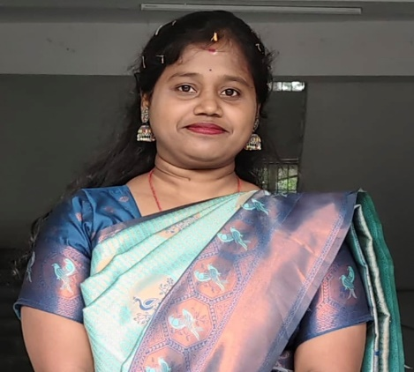
Official Address: SALIPUR AUTONOMOUS COLLEGE, SALIPUR
Email: pritimanjari.chhatoi566@gmail.com
Phone: 7377697006 ORCID/Research ID (if any):
Designation | Institution | From | To | Total  Experience
- Academic Qualifications
Degree | Specialization | University/ Board | Year | Percentage/ CGPA
10th |  | BSE,ODISHA | 2012 | 68.5%
12th | ARTS | CHSE, ODISHA | 2014 | 73%
Graduation | ARTS  EDUCATION | UTKAL  UNIVERSITY | 2017 | 74.78%
Post Graduation | EDUCATION | RAMADEVI UNIVERSITY | 2019 | 76.18%
B.Ed |  | ACHARYA  NAGARJUNA  UNIVERSITY ,  NAGARJUNA  NAGAR -  522510,  ANDHRA  PRADESH | 2021 | 83.09%
UGC/CSIR NET-JRF | ADMISSION  TO Ph.D.  ONLY | UGC -NET | DECEMBER 2025 | 91.87 Percentile
- Teaching Experience
LECTURER IN EDUCATION | LAKSHMI NARAYAN SAHU MAHAVIDYALAYA, JAGATPUR | 04.01.2020  And 06.11.2020 | 29.02.2020  And  30.04.2021 | 8 Months
LECTURER IN EDUCATION | SALIPUR  AUTONOMOUS  COLLEGE,  SALIPUR | 18th  DECEMBER  2021 | CONTINUING | 4 YEARS 2  MONTHS
- Courses Attended (Orientation/Refresher/FDP etc.)
Course | Date | University/ Organization | State/National / International
FDP | 9th FEBRUARY to  14th FEBRUARY  2026 | ANCHAL COLLEGE  AND KISS  UNIVERSITY | NATIONAL
WORKSHOP | 19th December 2025 | Jawaharlal Nehru Degree College | National
- Seminars / Conferences Attended / Participated
Dat  e | Topi  c | Organize d by | Sponsored By | Role (Participated/Presented/ Organized) | National / Internation  al
11th to 12th January 2019 | New Technology and Multimedia in Higher Education | PG Department of Education  Shailabala Women’s Autonomous College, Cuttack | Shailabala Women’s Autonomous College, Cuttack | Presented | National
24th February 2019 | Education for Peace and Harmony | Department of Education  Salipur Autonomous College, Salipur in collaboration with TEEKA FOUNDATION, BHUBANESWAR | Department of Education  Salipur Autonomous College, Salipur in collaboration with TEEKA FOUNDATION, BHUBANESWAR | Presented | International
25th February 2019 | Redefining Education in the New Millennium | B.Ed Self – Financing Department  Shailabala Women’s Autonomous College, Cuttack | B.Ed Self – Financing Department  Shailabala Women’s Autonomous College, Cuttack | Presented | National
6th and 7th March 2022 | Relevance of ICT in Education: Issues and Challenges | Department of Education  Kendrapara Autonomous College, Kendrapara in collaboration with TEEKA FOUNDATION, BHUBANESWAR | UGC | Presented | National
18th August 2022 | Yoga and Self Realization | Art of Bliss | Art of Bliss | Presented | State
12.02.2023 | Peace Education | Art of Bliss | Art of Bliss | Presented | International
24.11.2023 | Value Education | TEEKA Foundation in collaboration with Department of Education and Internal Quality Assurance Cell, Salipur Autonomous College | TEEKA Foundation in collaboration with Department of Education and Internal Quality Assurance Cell, Salipur Autonomous College | Presented | National
03.08.2025 | Contribution of Maharshi Vyasadev | Art of Bliss in collaboration with Department of Techer education Rajdhani college BBSR | Art of Bliss in collaboration with Department of Techer education Rajdhani college BBSR | Presented | Ntional
22.08.2025 | Value Education: A pathway to Peace and Harmony | Institute of education, Haladia (IQAC) | Institute of education, Haladia (IQAC) | Presented | National
14.11.25 | Blissful Life: Happy living in a Material World | Art of Bliss in collaboration with Central Sanskrit University, Sri Sadashiv campus, Puri | Art of Bliss in collaboration with Central Sanskrit University, Sri Sadashiv campus, Puri | Presented | International
- Research Publications
Title of the Paper |  | Name of the Journal |  | Impact Factor |  | ISSN No/ISBN NUMBER |  | Volume |  | Issue |  | Year
VALUE  EDUCATION: A  PATHWAY TO  PEACE AND  HARMONY |  | PEACE  EDUCATION-  TEEKA  FOUNDATION,  ODISHA,  BHUBANESWAR |  |  |  | 9789348148865 |  |  |  |  |  | 2025
CONTRIBUTIONS  OF MAHARSHI  VYASA DEV |  | CONTRIBUTIONS  OF INDIAN  SEERS AND  SAGES TO PROGRESS AND PROSPERITY OF HUMANITY : THEIR REFLECTIONS ON 21st CENTURY - TEEKA  FOUNDATION,  ODISHA,  BHUBANESWAR |  |  |  | 9789348148841 |  |  |  |  |  | 2025
- Membership in Organizations / Associations
Position Held | Organization (National/ State/International) | Type of  Membership | Activities  Conducted  (Subject Expert/  Guest Lecturer/  BOS Member/ Life Member  etc.)
- Areas of Specialization / Research Interests
EDUCATIONAL TECHNOLOGY
- Awards / Recognitions (if any)
Declaration
I hereby declare that the information provided above is true to the best of my knowledge.
Date: 20/02/26
Place: SALIPUR, CUTTACK
Priti Manjari Chhatoi
Signature

