CURRICULUM VITAE OF FACULTY MEMBERS

1. Personal Information
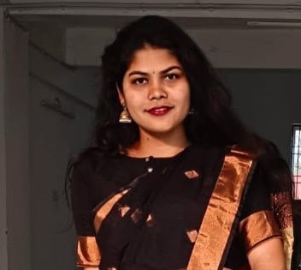
Full Name: Rasmita Das
Designation: Lecturer in Economics
Department: Economics
Date of Birth: 09/02/1997
Date of Joining:28/4/2023
Gender: Female
Official Address: Salipur Autonomous college, salipur
Email : dasrasmita9297@gmail.com
Phone: 8260680993
ORCID/Research ID (if any):

2. Academic Qualifications
Degree | Specialization | University/Board | Year | Percentage/CGPA
10th | Eng,odia, History, Geography, Math, Sanskrit | Board of Secondary Education, odisha | 2012 | 82.16%
12th | Economics,logic, psychology | Ravenshaw Junior college, Cuttack | 2014 | 80%
Graduation | , Economics | Ravenshaw University, Cuttack | 2017 | 70%
Post Graduation | Economics | Central University of Hyderabad | 2019 | 83.75%
M.Phil. | Economics | Jawaharlal Nehru University, New Delhi | 2022 | 60%
UGC/CSIR NET-JRF | Economics | University Grants commission | 2018
Ph.D. | Economics | Jawaharlal Nehru University, New Delhi | C Continuing

3. Teaching Experience
Designation | Institution | From | To | Total Experience
Lecturer | Salipur Autonomous college, salipur | 28/4/2023 | continuing | 2 yrs 10 months

4. Courses Attended (Orientation/Refresher/FDP etc.)
Course | Date | University/Organization | State/National / International
FDP | 16/12/2024 | Jawaharlal Nehru University | National

5. Seminars / Conferences Attended / Participated
Date | Topic | Organized By | Sponsored By | Role (Participated/Presented/Organized) | National / International

6. Research Publications
Title of the Paper | Name of the Journal | Impact Factor | ISSN No. | Volume | Issue | Year

7. Membership in Organizations / Associations
Position Held | Organization (National/State/International) | Type of Membership | Activities Conducted (Subject Expert/Guest Lecturer/BOS Member/Life Member etc.)

8. Areas of Specialization / Research Interests
Migration, Development economics,macroeconomics, labour Studies

9. Awards / Recognitions (if any)

Declaration
I hereby declare that the information provided above is true to the best of my knowledge.
Date: 19/02/2026
Place: Salipur
Signature

