CURRICULUM VITAE OF FACULTY MEMBERS

1. Personal Information
Full Name: SAHENAZ PARWEEN
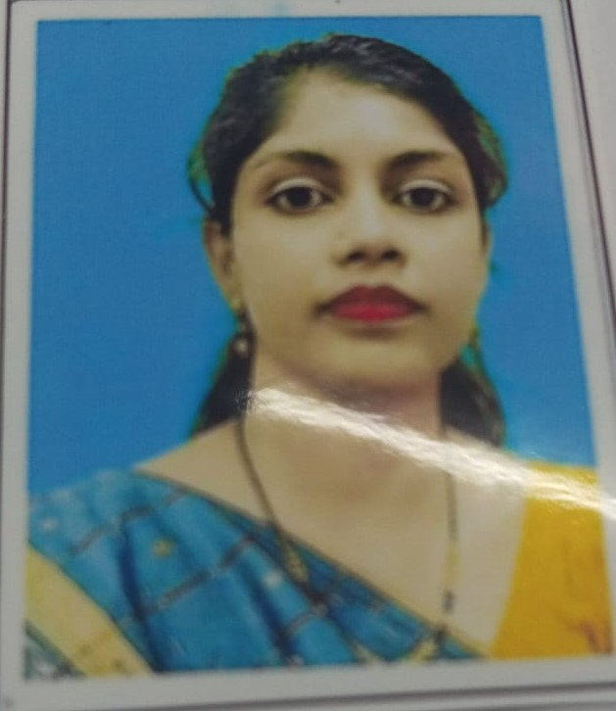
Designation: LECTURER
Department: PHILOSOPHY
Date of Birth: 10.05.1994
Date of Joining:20.08.2018
Gender: FEMALE Photo
Official Address: SALIPUR AUTONOMOUS COLLEGE, SALIPUR
Email: sahenaz.parween10@gmail.com
Phone:7978739771
ORCID/Research ID (if any):

2. Academic Qualifications
Degree | Specialization | University/Board | Year | Percentage/CGPA
10th | FLO,SLE,TLH,MATH | BSE, ODISHA | 2009 | 49.33%
12th | MIL,ENG,ECO,HIS,LOG,POL.SC | CHSE, ODISHA | 2011 | 58.83%
Graduation | PHILOSOPHY(HONS) | RAVENSHAW UNIVERSITY | 2014 | 61.6%
Post Graduation | PHILOSOPHY(VEDANTA) | RAVENSHAW UNIVERSITY | 2016 | 61%
M.Phil. | PHILOSOPHY | UTKAL UNIVERSITY | 2019 | 61.5%

3. Teaching Experience
Designation | Institution | From | To | Total Experience
LECTURER | SALIPUR AUTONOMOUS COLLEGE,  SALIPUR | 20.08.2018 | CONT…. | 7 YEAR  6 MONTH

4. Seminars / Conferences Attended / Participated
Date | Topic | Organized By | Sponsored By | Role (Participated/Presented/Organized) | National / International
11th-15th  NOVEMBER,  2025 | Artificial intelligence(AI) in higher education, A frame work for responsible integration. | Department Of Philosophy, Utkal University. | RUSA 2.0 | Participated | National
3th-4th January,  2026 | Wellness in oneness: Integrating Artificial Intelligence Across Disciplines For Implementing Advaita Vedanta Practice. | Utkal University in collaboration with Heart Lab, Suffolk University, USA and Microsoft Associates, USA. | Department Of Philosophy, Utkal University. | participated | International
16th-17th January,  2026 | Reason, Revolution And Reconstruction In Indian Philosophy, Decoding Daya Krishna Legacy. | DIC, Department Of Philosophy, Ravenshaw University. | DIC, Department Of Philosophy, Ravenshaw University. | participated | International
24th-25th January,2026 | 38th Annual Conference, AOPA | Department Of Utkal University. | All Odisha Philosophical  Association. | participated | State

5. Membership in Organizations / Associations
Position Held | Organization (National/State/International) | Type of Membership | Activities Conducted (Subject Expert/Guest Lecturer/BOS Member/Life Member etc.)
Member | Salipur Autonomous College, Salipur |  | BOS Member
Member | State |  | Life Member

Declaration
I hereby declare that the information provided above is true to the best of my knowledge.
Date: 27.02.2026
Place: SALIPUR
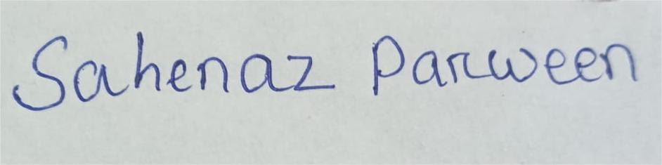
Signature

