CURRICULUM VITAE OF FACULTY MEMBERS

1. Personal Information
Full Name: Sushre Sangita Jena
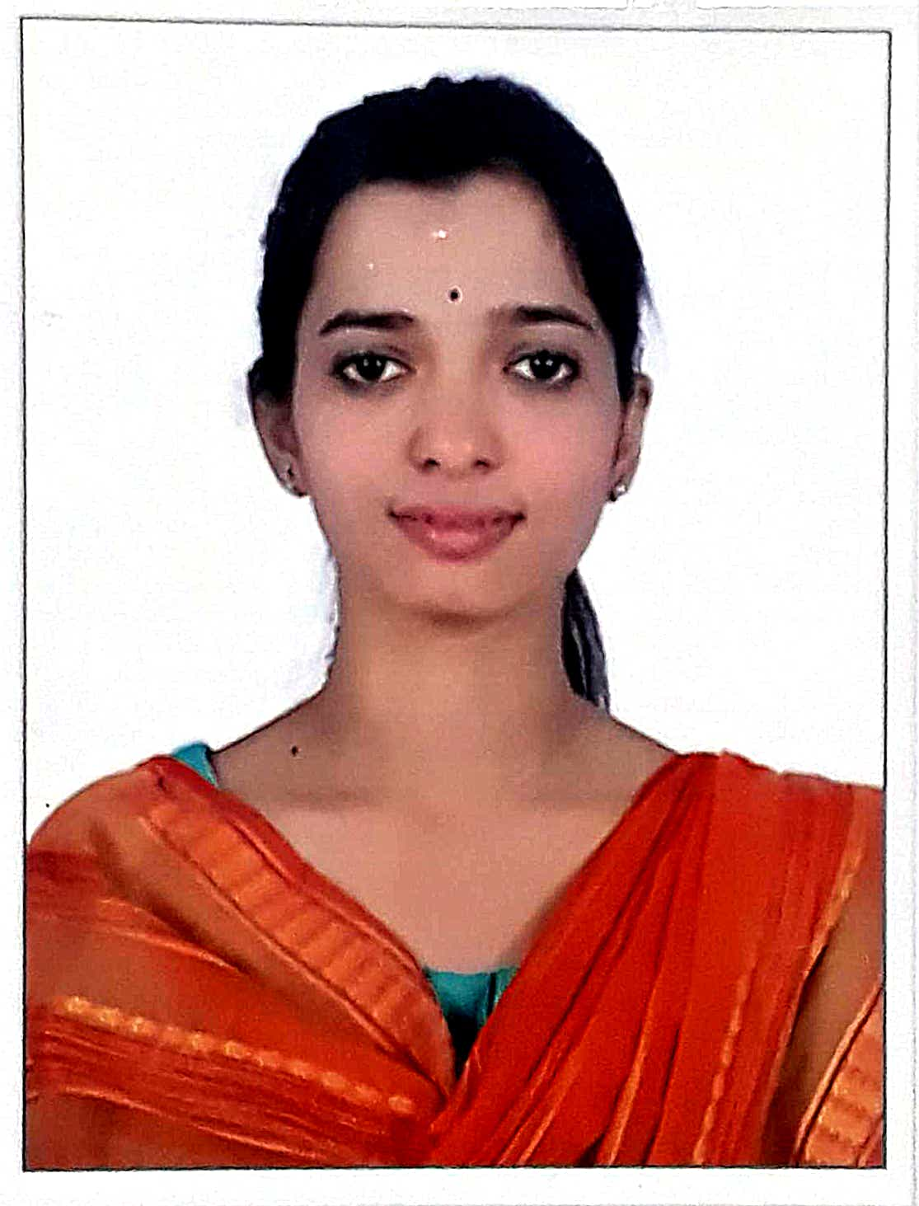
Designation: Lecturer
Department: Political Science
Date of Birth: 07/01/1998
Date of Joining: 04/03/2024
Gender: Female Photo
Official Address: Salipur Autonomous College, Salipur, Cuttack.
Email: sushre1998@gmail.com
Phone: 7978217208
ORCID/Research ID (if any):

2. Academic Qualifications
Degree | Specialization | University/Board | Year | Percentage/CGPA
10th |  | BSE, Odisha | 2012 | 60
12th | Arts | CHSE, Odisha | 2014 | 60
Graduation | Political Science | Utkal University, Odisha | 2017 | 56
Post Graduation | Political Science | Ravenshaw University, Odisha | 2019 | 75
M.Phil.
UGC/CSIR NET-JRF | Political Science | UGC | 2020
Ph.D.

3. Teaching Experience
Designation | Institution | From | To | Total Experience
Lecturer | Salipur Autonomous College | 04/03/2024 | Till Present | 1 Year 11 Months

4. Courses Attended (Orientation/Refresher/FDP etc.)
Course | Date | University/Organization | State/National / International
5 Days Teacher Training Programme | 21/01/2025 to 25/01/2025 | CHSE, Odisha | State

5. Seminars / Conferences Attended / Participated
Date | Topic | Organized By | Sponsored By | Role (Participated/Presented/Organized) | National / International
18/12/2025 | “Writing and Funding Research Proposals: From Idea to Approval” | Internal Quality Assurance Cell (IQAC), Kendrapara Autonomous College, Kendrapara, Odisha |  | Participated | National

6. Research Publications
Title of the Paper | Name of the Journal | Impact Factor | ISSN No. | Volume | Issue | Year

7. Membership in Organizations / Associations
Position Held | Organization (National/State/International) | Type of Membership | Activities Conducted (Subject Expert/Guest Lecturer/BOS Member/Life Member etc.)
Faculty Member | State |  | BOS

8. Areas of Specialization / Research Interests
Political Theory, Political Thought, International Relations, Foreign affairs etc.

9. Awards / Recognitions (if any)

Declaration
I hereby declare that the information provided above is true to the best of my knowledge.
Date: 17/02/2026
Place: Salipur
Sushre Sangita Jena
Signature

