CURRICULUM VITAE OF FACULTY MEMBERS

1. Personal Information
Full Name: IPSITA DASH
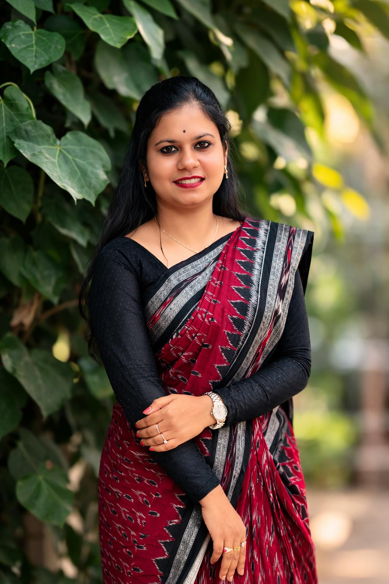
Designation: LECTURER
Department: SANSKRIT
Date of Birth: 16/06/1999
Date of Joining:18/10/2022
Gender: FEMALE Photo
Official Address: SALIPUR AUTONOMOUS COLLEGE,SALIPUR
Email: ipsitadash124@gmail.com
Phone: 7749042370
ORCID/Research ID (if any):

2. Academic Qualifications
Degree | Specialization | University/Board | Year | Percentage/CGPA
10th |  | BSE ODISHA | 2014 | 79.5
12th |  | CHSE ODISHA | 2016 | 79
Graduation | SANSKRIT HONOURS | UTKAL UNIVERSITY | 2019 | 81
Post Graduation | SANSKRIT GRAMMAR | UTKAL UNIVERSITY | 2021 | 78
M.Phil.
UGC/CSIR NET-JRF
Ph.D.

3. Teaching Experience
Designation | Institution | From | To | Total Experience
LECTURER | SALIPUR AUTONOMOUS COLLEGE,SALIPUR | 18/10/2022 | TILL DATE | 4YEARS

4. Seminars / Conferences Attended / Participated
Date | Topic | Organized By | Sponsored By | Role (Participated/Presented/Organized) | National / International
28/12/2024 | APPLIED SCIENCE IN SANSKRIT | UDAYANATH AUTONOMOUS COLLEGE | UGC | PARTICIPATED | NATIONAL

Declaration
I hereby declare that the information provided above is true to the best of my knowledge.
Date:03/03/2026
Place: SALIPUR
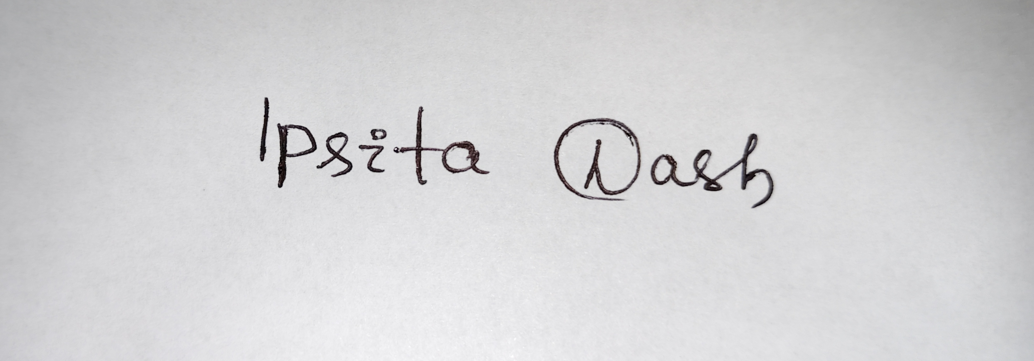
Signature

