CURRICULUM VITAE OF FACULTY MEMBERS

1. Personal Information
Full Name: Mrs. Shibani Patra
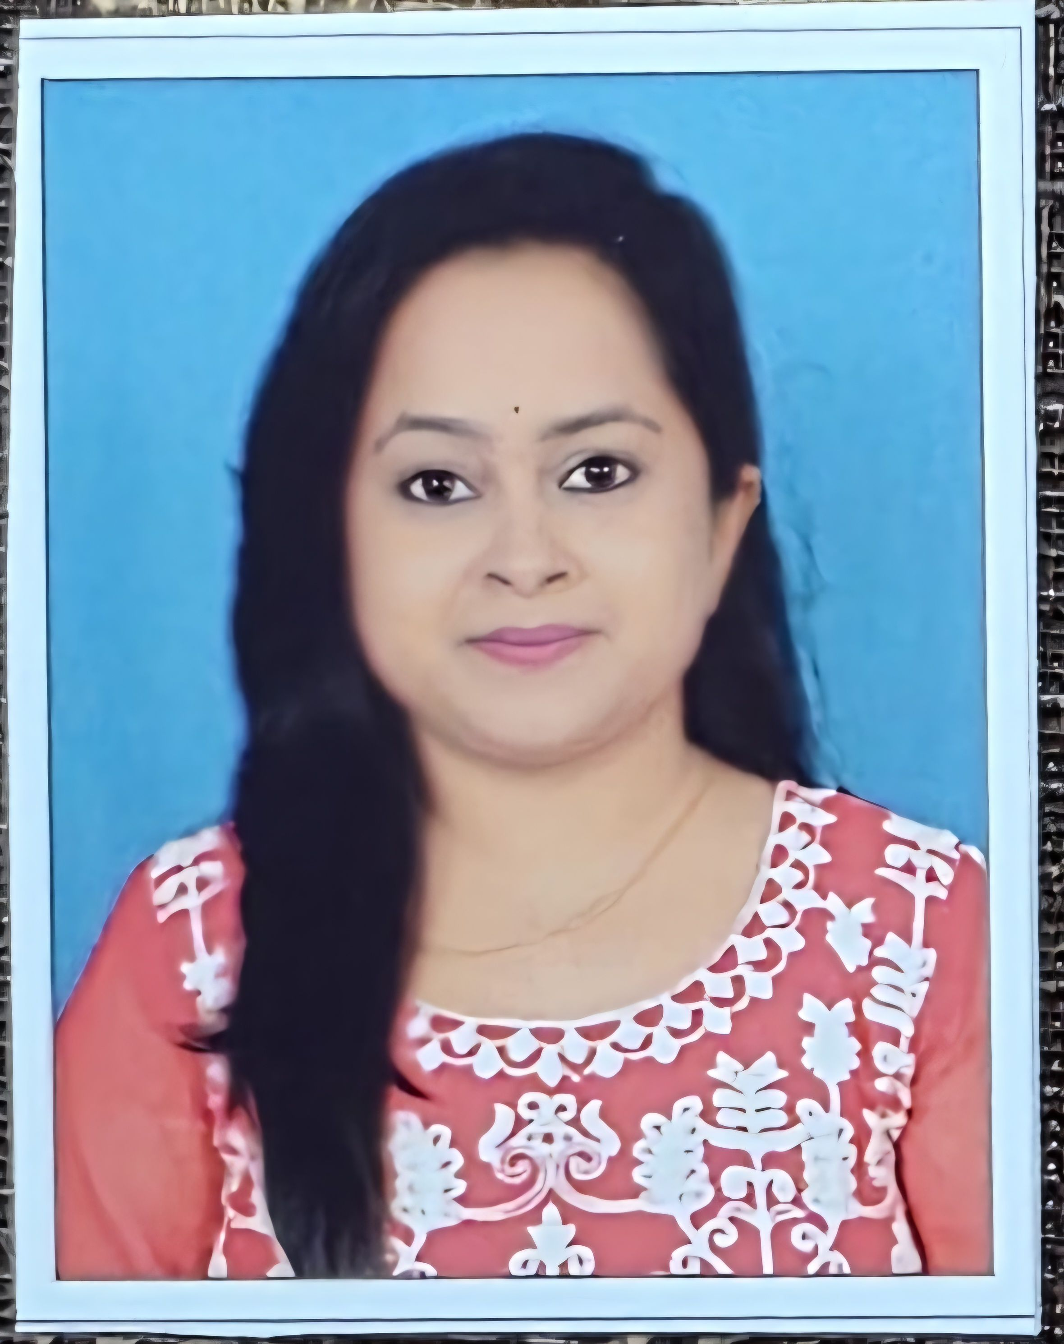
Designation: Lecturer in Home Science
Department: Home science
Date of Birth: 16/05/1996
Date of Joining: 06/03/2024
Gender: Female
Official Address: Salipur Autonomous College, Salipur, Cuttack
Email: patrashibani888@gmail.com
Phone: 8328875612
ORCID/Research ID (if any):

2. Academic Qualifications
Degree | Specialization | University/Board | Year | Percentage/CGPA
10th |  | BSE, Odisha | 2012 | 72.83%
12th |  | CHSE, Odisha | 2014 | 75.83%
Graduation | Home science, Arts | Sambalpur University | 2017 | 67%
Post Graduation | Home science | Rama Devi University | 2019 | 80.47%
M.Phil. | Home science | Sambalpur University | 2020 | 81%
UGC/CSIR NET-JRF | Home science (JRF) | UGC | 2023
Ph.D.

3. Teaching Experience
Designation | Institution | From | To | Total Experience
Guest Faculty | SM Govt Women’s college | 18/10/2022 | 18/01/2024 | 2
Lecturer, HOD | Salipur Autonomous College, Salipur, Cuttack | 06/03/2024 | Continue

4. Courses Attended (Orientation/Refresher/FDP etc.)
Course | Date | University/Organization | State/National / International
Faculty Training Program | 15-09-2025 to  17-09-2025 | Department of Higher Education | State

5. Seminars / Conferences Attended / Participated
Date | Topic | Organized By | Sponsored By | Role (Participated/Presented/Organized) | National / International
04-08-2025 | World breast feeding week | Sri Sri University | Sri Sri University | Participated | National
30-01-2026 | Significance role of lifestyle management (Diet + exercise) | Department of Home science | Department of Home science | Organized | National
06-02-2026 | Gender, social inclusion and union budget | IMPRI | IMPRI | Participated | National
17-02-2026 to 18-02-2026 | Life style diseases and nutrition: challenges and measures | Shailabala women’s autonomous college, Cuttack | Shailabala women’s autonomous college, cuttack | Participated | National

6. Research Publications
Title of the Paper | Name of the Journal | Impact Factor | ISSN No. | Volume | Issue | Year

7. Membership in Organizations / Associations
Position Held | Organization (National/State/International) | Type of Membership | Activities Conducted (Subject Expert/Guest Lecturer/BOS Member/Life Member etc.)
Member of BOI | State |  | Board of studies  Banki autonomous college, Cuttack

8. Areas of Specialization / Research Interests
Food and Nutrition, Human Development

9. Awards / Recognitions (if any)

Declaration
I hereby declare that the information provided above is true to the best of my knowledge.
Date: 18-02-2026
Place: Salipur Shibani Patra
Signature

